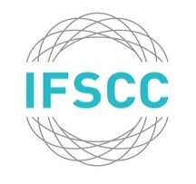m
2024 MAISON G DE NAVARRE YOUNG SCIENTIST ESSAY PRIZE

ENTRY FORM to accompany essay
Contest open to any scientist no more than 35 years old* as of 1 April 2024.

Applicants should submit an essay of between 500 and 3,000 words on one of five topics chosen below. Starting in 2024, the top three essays chosen by the prize committee will undergo virtual interviews with questions on their essays. These interviews will be conducted by a group of members of the IFSCC Praesidium. The individual who provides the most exceptional answers, as collectively agreed upon by the prize committee, will then be declared the winner.

Please email your essay with this signed form no later than 1 April 2024 to the IFSCC Secretary General (secretary@Ifscc.org), cc'ing the President of your National Society. Kindly put "MGdN 2024 submission" in the subject line of your email. All submissions received will be emailed a confirmation email. The announcement of the winner will be made at the end of June 2024.

What’s the topic of your essay?
- The Impact of Technology on Beauty Products
- Sustainability and Circular Economy in Cosmetic Formulations
- The Role of Microbiome Research in Skincare
- Inclusive Beauty - Addressing Diversity in Cosmetic Science
- Psycho-Cosmetics - Exploring the Psychology of Beauty

First name: Last name:
Date of Birth: Age:
Company:
Title:
Company Address:
Email:
Name of the IFSCC Member Society to which you belong:
I confirm that the above information is correct and that the essay submitted is my own work.

Signature Date

